Support the Cavendish
Square Petition


This is what they promised

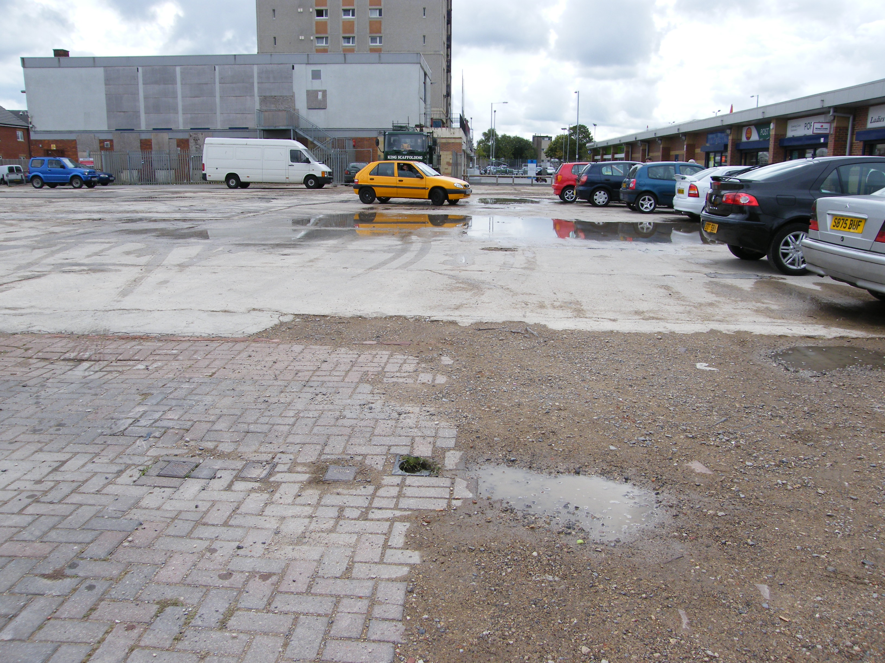

This is what we got

Get copies of the petition from The Shop

Parks & East Walcot Forum & SWAP

